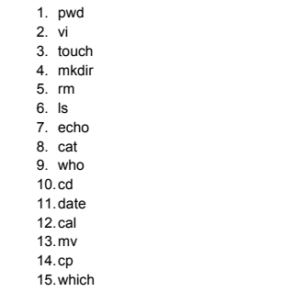

1. Pwd

Displays the present working directory



1. Vi

Editor

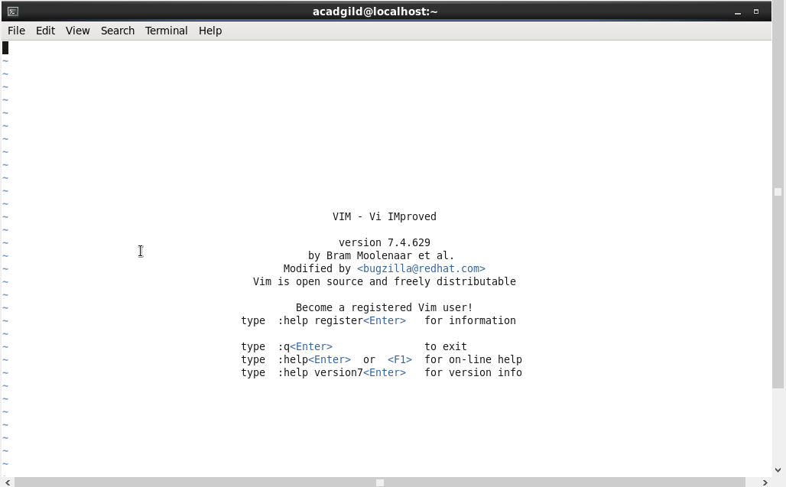

1. Touch

The touch command is a standard program for Unix/Linux operating systems, that is used to create, change and modify timestamps of a file.

* -a, change the access time only
* -c, if the file does not exist, do not create it
* -d, update the access and modification times
* -m, change the modification time only
* -r, use the access and modification times of file
* -t, creates a file using a specified time

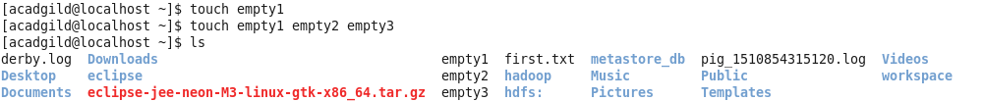

1. Mkdir

Makes directory as required

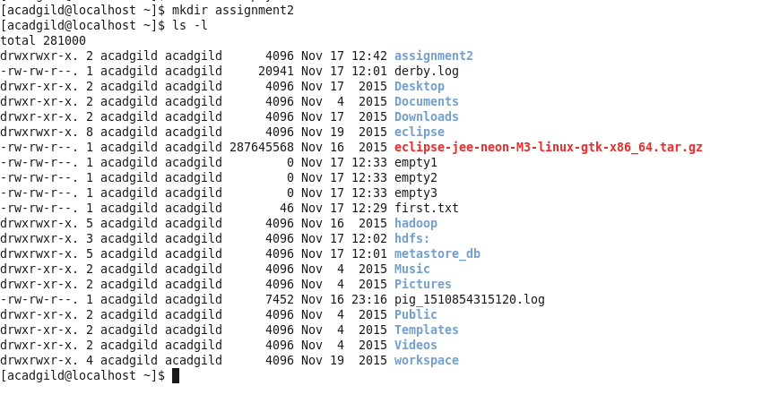

1. Rm

Removes directory/files as specified

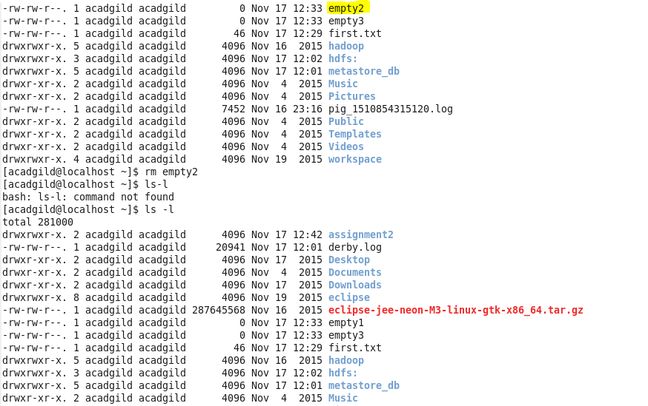

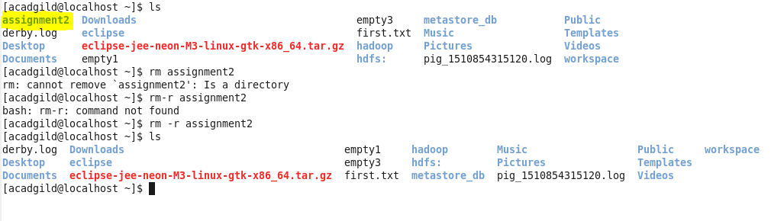

1. Ls

Lists files and directories.

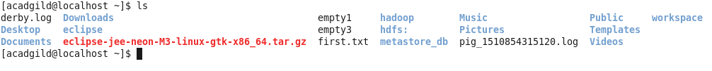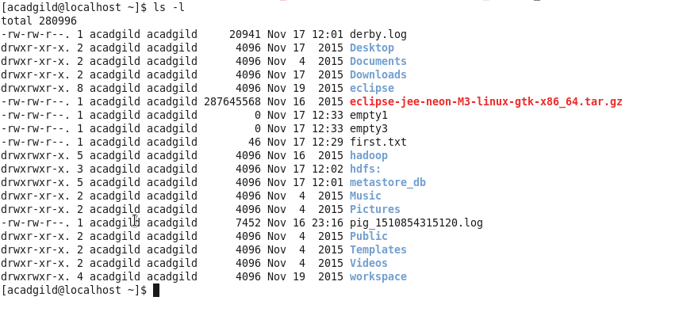7. Echo

echo is one of the most commonly and widely used, that in scripting language and batch files to display a line of text/string on standard output or a file.

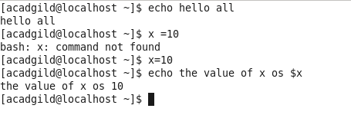  
8. Cat

cat is one of the most frequently used [commands](http://www.linfo.org/command.html) on [Unix-like](http://www.linfo.org/unix-like.html) [operating systems](http://www.linfo.org/operating_systems_list.html). It has three related functions with regard to text files: displaying them, combining copies of them and creating new ones.

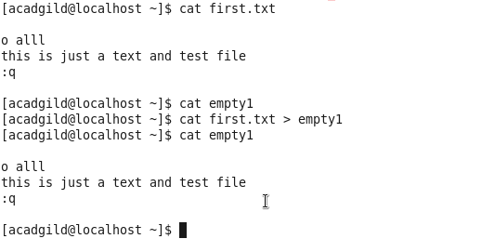

9. who

Display who is on the system**.**

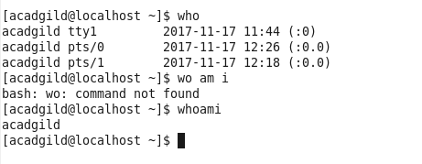

10. cd

Change directory..

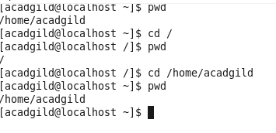

11. date

Date print or set the sytem date

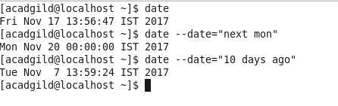

12. Cal

Displays calendar.

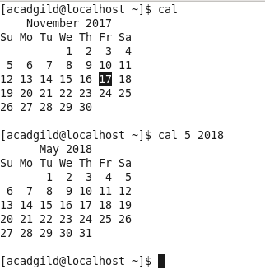

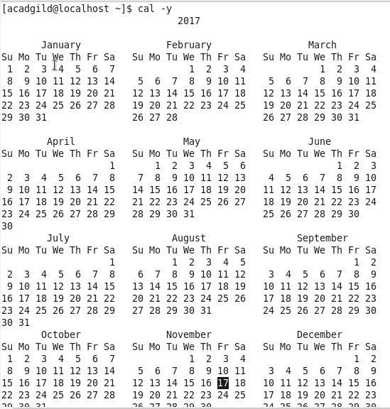

13. mv

Moves or Renames file. Doesn’t keep a copy as done by cp command

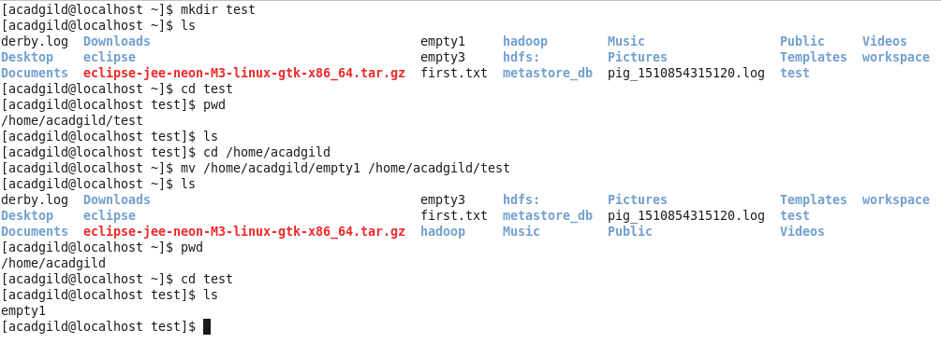

14. cp

Copies file to other location

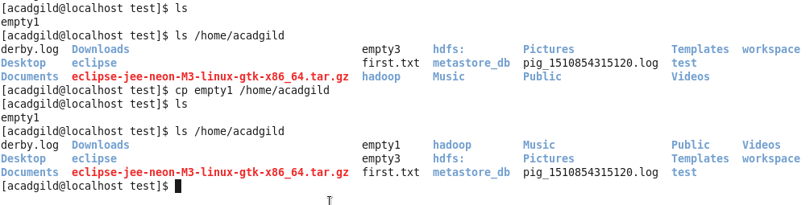

15. which

Locate the [executable file](https://www.computerhope.com/jargon/e/execfile.htm)

